# Site Flow and Sketches

## Step 1: Competitive Analysis

|  |  |
| --- | --- |
| Competitor Site 1: Amazon URL: https://www.amazon.com AnalysisWhat is good about this site?  1. There is a search bar on the top of the main page that makes it convenient for customers to search for the things they want to buy. 2. There is a browsing history button on the main page that can help the customers keep track of what they have looked at several days ago. 3. There is a cart button on the main page that can facilitate the customers to take a look at the things they have already chosen to buy and add more products into it.  What is bad about this site?  1. There are too many ads embedded on the page that customers may accidentally click into the ads they don’t want to see. 2. There are too many buttons on the top of the page and they are too small and very close to each other. This may cause customers to accidentally click into the wrong buttons. 3. There are too many colors on this site that may lead to blurred vision for the customers. | Competitor Site 2s: Ted Talk URL: https://www.ted.com/#/ AnalysisWhat is good about this site?  1. There is a search bar on the top of the main page that makes it convenient for users to search for the speech they want to watch. 2. There is a ted talk recommendation area that can help users choose the speeches they are most interested in. 3. The newest talk is also shown on the site so that the users can get to know the newest topics easily.  What is bad about this site?  1. The words in the tag showing different categories of ted talk are a little bit small. 2. The words at the bottom of the main page showing the options available for users to click are a little bit small. 3. The titles of the list of speech videos under different categories are a little bit small. |

### Competitor 1 Pages

#### Page (or Screen) where you ask “What should I do tonight?”

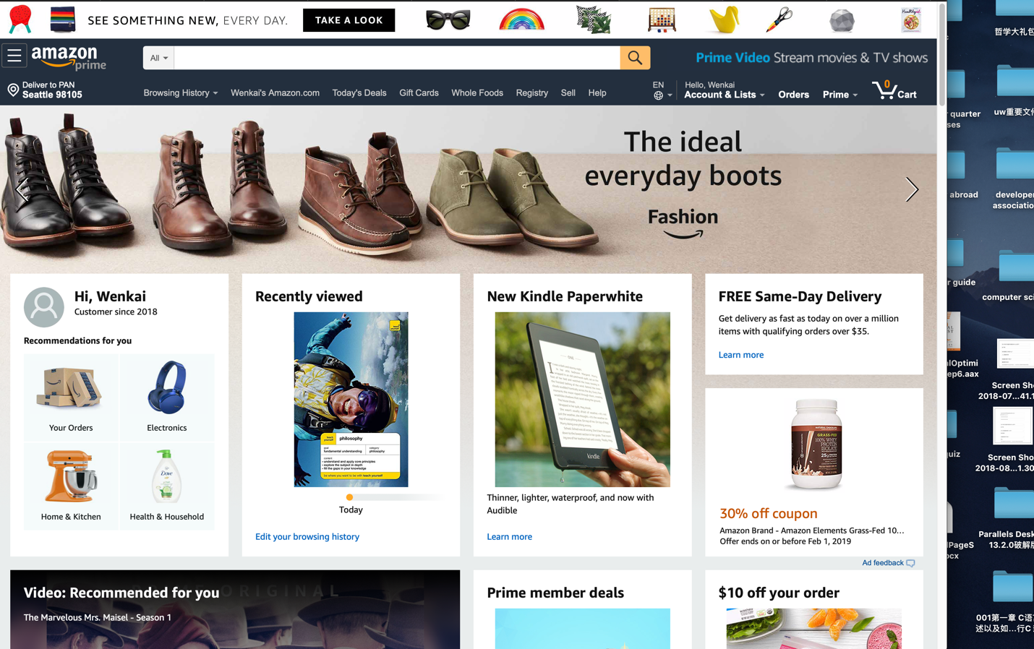

#### Pages (or Screens) look for the answer

#### Page where you get an answer

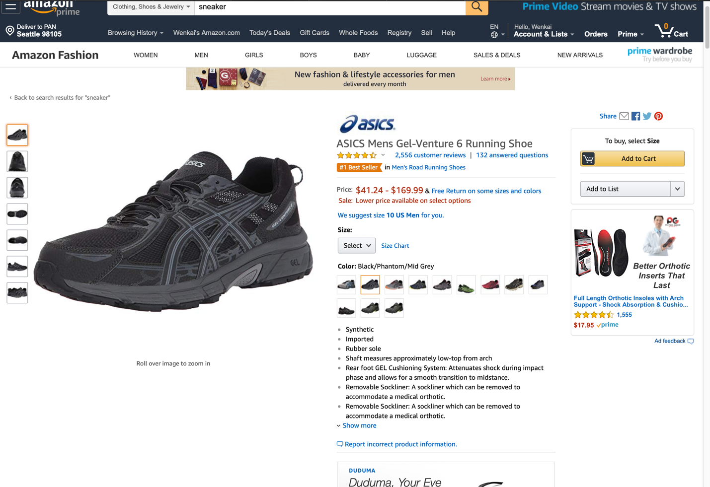

### Competitor 2 Pages

#### Page (or Screen) where you ask “What should I do tonight?”

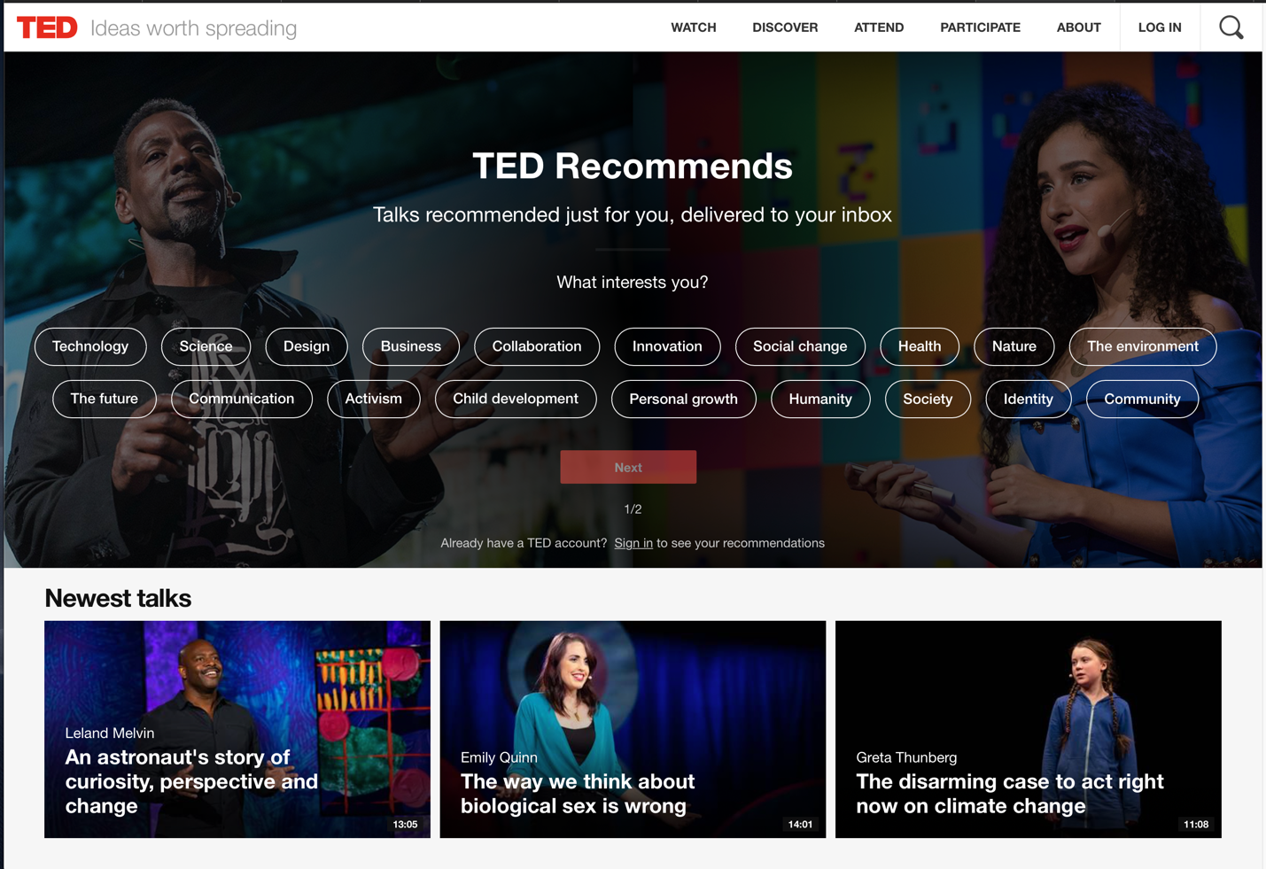

#### Pages (or Screens) look for the answer

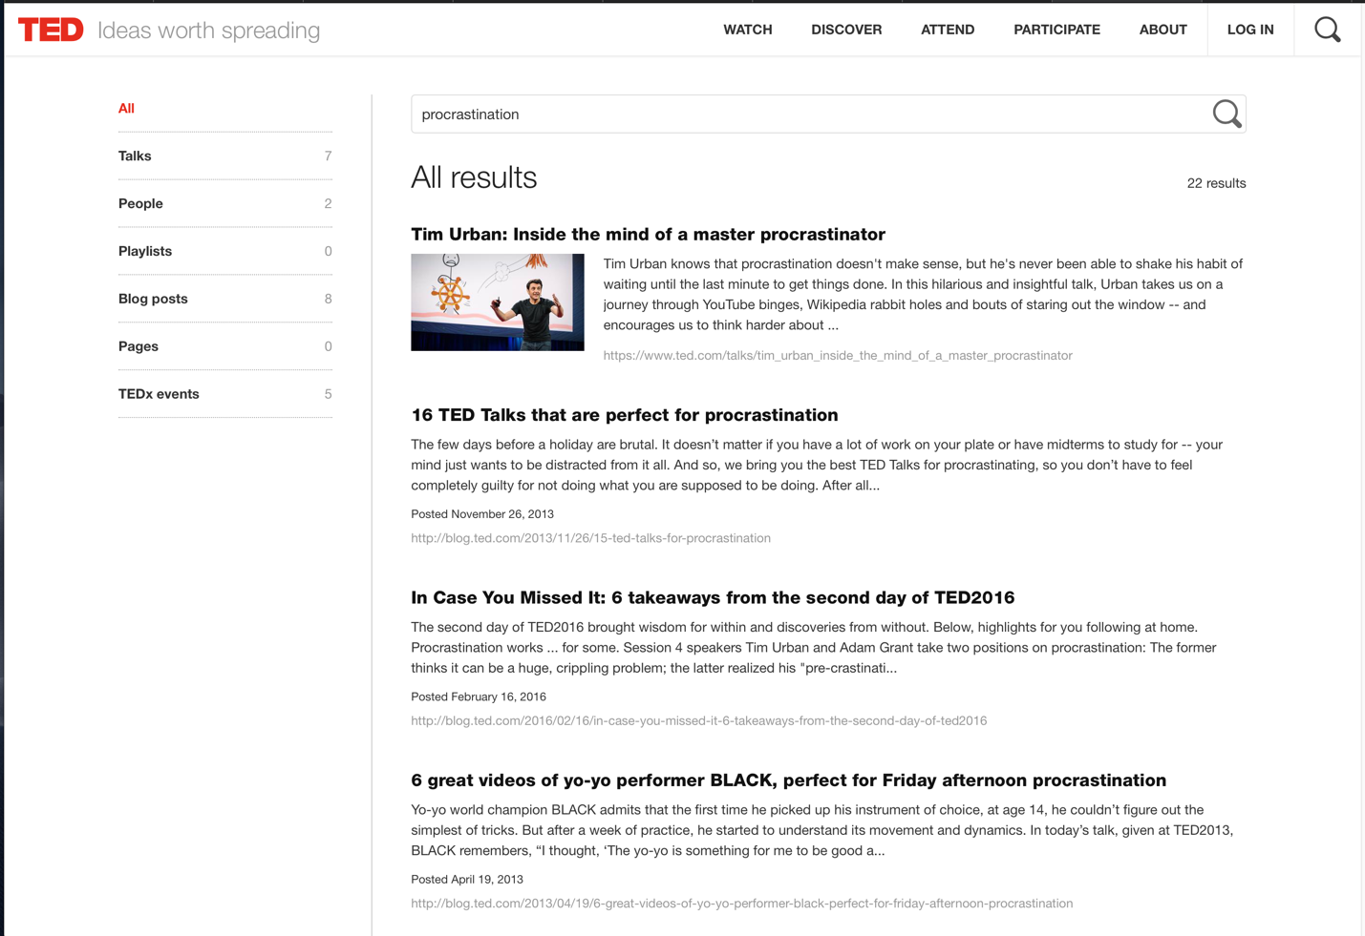

#### Page where you get an answer

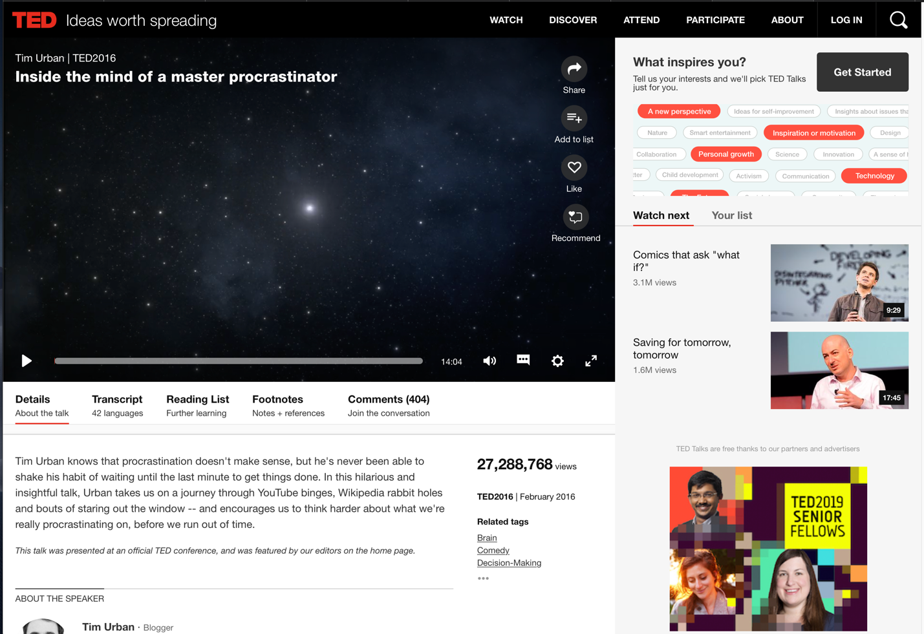

## Step 2: Sketch One Competitor Flow

### Favorite Competitor: Page Flow Sketch

Pages sketched as boxes for the flow between pages (or screens) where you ask “What should I do tonight?”, look for the answer, and get an answer. Arrows drawn between the boxes show how the pages are connected by clicks. Inside the page boxes details include:

* Where you ask the question
* Where the navigation is that allows you to find things to do
* Where the details of the “things to do” are displayed
* Where you click to move from page to page

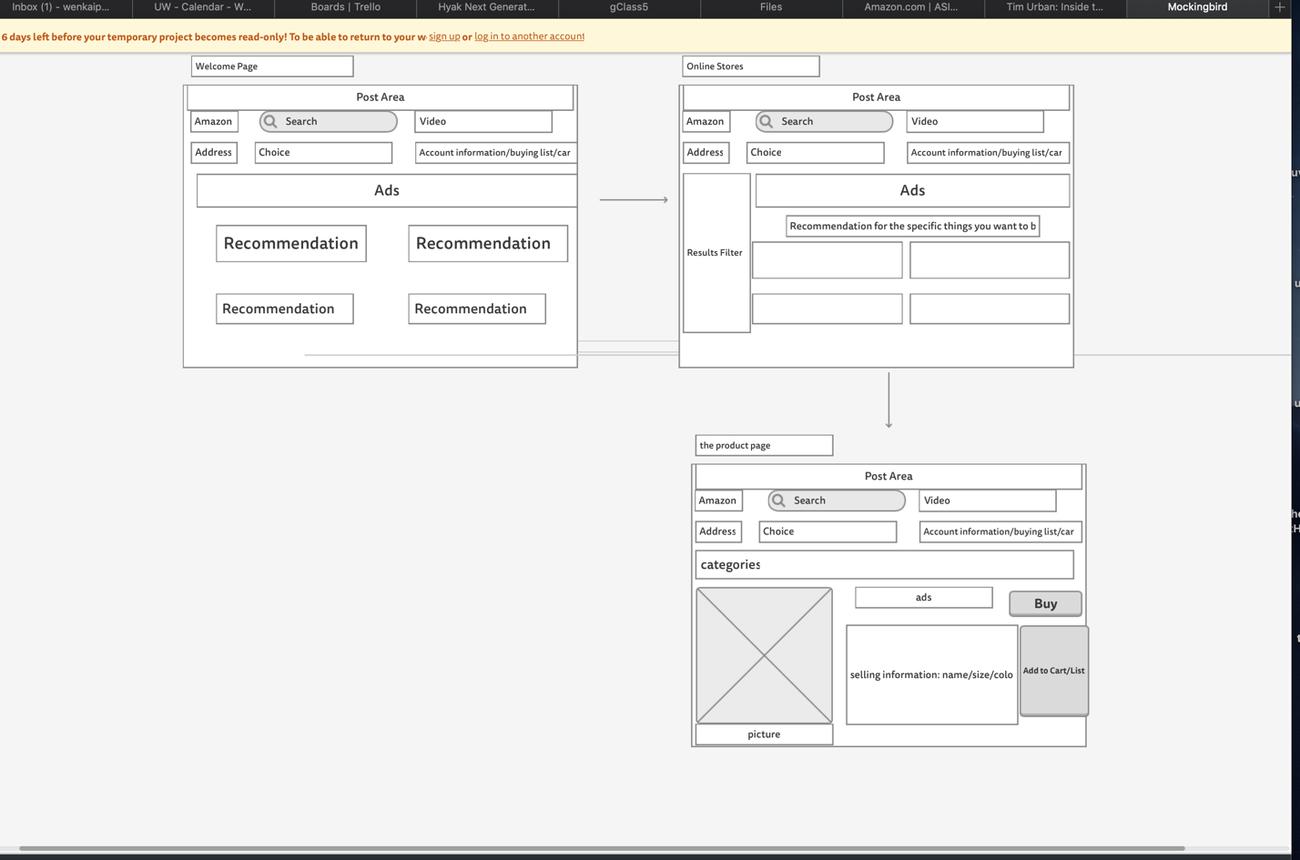

## Step 3: Sketch YOUR Flow

### My Site Name

Assignment Killer

#### Sketch of My Page Flow

Pages sketched as boxes for the flow between pages (or screens) where you ask “What should I do tonight?”, look for the answer, and get an answer. Arrows drawn between the boxes show how the pages are connected by clicks. Inside the page boxes details include:

* Where you ask the question
* Where the navigation is that allows you to find things to do
* Where the details of the “things to do” are displayed
* Where you click to move from page to page

